**INDEX**

|  |  |  |
| --- | --- | --- |
| **SR.NO.** | **CHAPTER NAME** | **PAGE NO.** |
| **1** | **Introduction to Project**  Introduction to System  Modules of the system |  |
| **2** | **Organization Profile**  Organization Chart |  |
| **3** | **Proposed System**  Exitisting System  Need of Computerization  Objectives of System |  |
| **4** | **System Design**  Feasibility Study  Fact Finding Technique  Diagram  Hardware and Software Requirement |  |
| **5** | **User Manual**  User Guidline |  |
| **6** | **Input Screens** |  |
| **7** | **Output Screens** |  |
| **8** | **Limitations and Suggestions** |  |
| **9** | **Bibliography** |  |
|  |  |  |

**Chapter-1**

**Introduction**

**Introduction to system:-**

An Employee Tracking System (ETS) is a specialized web application developed to assist organizations in managing and organizing employee information efficiently. The system serves as a centralized platform where all essential employee-related data and processes are stored, tracked, and managed. It aims to streamline administrative tasks, reduce manual errors, and improve overall productivity within the organization.

The ETS typically encompasses various functionalities, such as storing personal information, managing work schedules, tracking attendance, processing payroll, evaluating performance, and facilitating communication between employees and management. By automating these processes, the system enhances accuracy, compliance with labor regulations, and transparency in operations.

In essence, an Employee Tracking System is a powerful tool designed to optimize human resources management and contribute to the effective functioning of an organization.

**The details of the system are as follows:**

The Employee Tracking System (ETS) web application is a software solution that allows organizations to efficiently manage various aspects of employee-related processes. It aims to streamline administrative tasks, improve operational efficiency, and enhance communication between employees and management. This system is particularly useful in organizations with large workforces, as it automates and centralizes employee information, making it more accessible, secure, and easier to manage.

The system typically includes a wide range of features, which are tailored to meet the needs of both employees and administrators. One of the primary components is a **database** that stores all relevant employee information. This could include personal details, contact information, work history.

For **administrators**, the system provides the ability to easily update and manage employee data. They can add new employees, edit existing records, track attendance, and manage tasks like approving leave requests. The system typically includes an **employee dashboard** that presents all critical information in one place, making it easier to access and monitor employee activities.

**Employees** can access the system via a self-service portal, where they can view and update their personal information, check attendance records, request time off, and view their payslips. This self-service aspect reduces the workload for administrators and ensures that employees have direct access to relevant information. It can also be a source for employees to communicate their concerns, feedback, or requests.

The **attendance management** feature allows the system to record employee monitor working day, track absences, and manage leave requests. It ensures that this data is automatically integrated .saving time and preventing errors.

Another essential component is the **payroll management** system.

**Reports and Analytics** are another important feature, as they provide administrators departments with insights into employee performance, attendance trends, and overall workforce health.

**Modules of the system:**

• Employee Information Management

• Employee Leave and Vacation Management

• Employee Performance Management

• Administrators Analytics and Reporting

* Task and Project Management

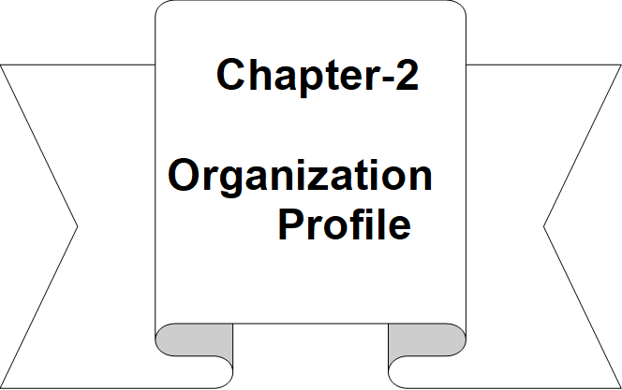**2.1 Organization Chart**

**administrators**

**Employee**

**Chapter-3**

**Proposed**

**System**

**3.1 Existing system:-**

An **Employee Tracking System (ETS)** refers to a software solution designed to streamline and automate the processes involved in managing employees within an organization. The system focuses on handling various aspects of the employee lifecycle, from recruitment to performance management, attendance. Here's a theoretical breakdown of an **Employee Tracking System** (ETS).

**Drawback of Existing System:**

1. **Tremendous paper work:**

• **Problem:**  
Many existing ETS solutions still rely heavily on physical documentation for various HR processes, such as employee records, performance reviews, training materials, payroll, leave applications, and more. Even in systems that are partly digital, paperwork remains a common aspect of the workflow.

• **Impact:**

1. **Inefficiency:** Manual paperwork increases the time and effort required for tasks like employee onboarding, record-keeping, and updating employee details.
2. **Data Loss Risk:** Physical records are prone to being lost, damaged, or destroyed, leading to gaps in employee data or compliance violations.
3. **Space Consumption:** Storing physical documents requires a lot of physical space and often involves complex filing systems, which can be difficult to maintain and locate when needed.
4. **Human Error:** The more paperwork involved, the higher the chance of human errors in data entry, filing, or calculations.
5. **Environmental Impact:** Extensive use of paper contributes to unnecessary environmental waste, especially if it's printed repeatedly for documentation or compliance purposes.

**More man power is required:**

•**Problem:**  
Many existing ETS platforms, especially older or manual systems, require a substantial amount of human involvement for tasks that could otherwise be automated. This could include data entry, verifying information, maintaining records, and ensuring compliance. In many cases, HR departments have to rely on multiple employees to handle routine administrative tasks that could otherwise be streamlined with more advanced automation.

• **Impact:**

* **Increased Operational Costs:** More employees are needed to perform administrative tasks that are time-consuming, such as manually processing payroll, tracking attendance, or handling employee requests for leave. This increases overhead costs.
* **Time-Consuming Processes:** Routine tasks such as entering employee data, manually updating attendance records, calculating leave balances, or generating performance reports consume valuable time and slow down HR operations.
* **Inconsistent Results:** With a larger number of people handling HR processes, the potential for inconsistencies or errors increases. Variations in how tasks are completed can lead to problems like missed deadlines, payroll discrepancies, or incorrect employee information.
* **Reduced Employee Productivity:** Employees who are involved in manual, repetitive HR tasks often don't have time to focus on strategic or value-added activities. This leads to overall reduced productivity and can create dissatisfaction among HR personnel.
* **Employee Burnout:** Having more staff perform repetitive, low-value tasks can lead to burnout and lower morale for HR staff. Instead of focusing on employee well-being and development, they may be bogged down with paperwork.

**3.2 Need of computerization**

With the evolution of computer technology the dimension of the computer have stunk while increasing its power and speed. Advanced technology of computer has valuable application in hotel are-

1. Structural design
2. hotel management
3. Estimation and costing
4. Architectural and interior design

5. Financial management

**3.3 Objectives of system**

The **Objectives of an Employee Tracking System (ETS)** typically focus on improving efficiency, accuracy, and communication within an organization regarding its workforce. Here are the key objectives:

1. **Centralized Employee Data Management**:
   * Maintain a single database with all employee details, such as personal information, contact details, job positions, work history, and performance.
2. **Streamlined Recruitment and Onboarding**:
   * Automate the process of posting job openings, receiving applications, conducting interviews, and processing new hires through a structured onboarding process.
3. **Time and Attendance Management**:
   * Track employee attendance, working hours, overtime, leaves, holidays, and absences. Automating this process minimizes errors and ensures accurate payroll.
4. **Performance Evaluation**:
   * Enable regular performance reviews and goal tracking. This helps in managing employee growth and identifying areas for improvement.
5. **Employee Leave Management**:
   * Track and manage vacation, sick leave, personal days, and other types of leave requests, ensuring there are no conflicts and that employees follow the company policy.
6. **Employee Development and Training**:
   * Keep track of employees' skills, certifications, and training programs. Help identify development needs and create training plans for career progression.
7. **Compliance and Reporting**:
   * Ensure adherence to labor laws, health and safety regulations, and company policies. Automate the generation of reports for audits and compliance purposes.
8. **Enhanced Communication and Collaboration**:
   * Foster communication between employees and HR through messaging systems, announcements, or notices, ensuring that everyone is on the same page.
9. **Employee Self-Service Portal**:

* Allow employees to access their records, request leave, view payslips, and update personal details, reducing HR's workload.

1. **Employee Retention and Satisfaction**:

* Monitor job satisfaction, gather feedback, and implement changes based on employee concerns, improving retention and overall workplace culture.

**Chapter-4**

**System**

**Design**

**4.1 FEASIBILITY STUDY**

The most important part of every system is the feasibility study. It provides technical, operation and economical feasibility. We discus all these three parts in details.

**Technical Feasibility:-**

• **System Requirements:** Assess the hardware and software requirements needed to develop and run the EMS.

• **Technology Stack:** Determine the appropriate technology stack (e.g., programming languages, databases, frameworks) for the system.

• **Integration:** Evaluate how the EMS will integrate with existing systems and software within the organization.

**Operational Feasibility:-**

• **User Needs:** Identify the needs of the users (e.g., HR department, employees) and ensure the system meets these needs.

• **Training:** Plan for training sessions to help users understand and effectively use the EMS.

• **Maintenance:** Consider the long-term maintenance and support required for the system.

**Economical Feasibility:-**

1. • **Cost Analysis:** Estimate the costs involved in developing, implementing, and maintaining the EMS.
2. • **Budget:** Ensure the project fits within the organization's budget.
3. • **Return on Investment (ROI):** Calculate the potential ROI by comparing the costs with the expected benefits, such as improved efficiency and reduced administrative workload.
   1. **FACT FINDING TECHNIQUE**

Fact-finding techniques are essential for gathering information and requirements when developing an Employee Tracking System (ETS). Here are some common techniques used:

**1. Sampling of Existing Documentation**

* **Description:** Review existing documents, forms, and databases to understand the current system and identify areas for improvement.
* **Example:** Analyzing employee records, payroll reports, and HR policies.

**2. Research and Site Visits**

* **Description:** Visit other organizations or research similar systems to gather insights and best practices.
* **Example:** Observing how other companies manage their employee data and processes.

**3. Observation**

* **Description:** Observe the work environment and processes to identify inefficiencies and areas for improvement.
  1. **Diagrams**

**4.3.1 Context Level Diagram:**

Admin

Employee

View Profile

Add/Edit/Delete

Employee Records

Performance Task

Assing Task and

Manage Task

Generate Leave

Reports

Approve/Reject Leave

Requests

**DATA FLOW DIAGRAM:-**

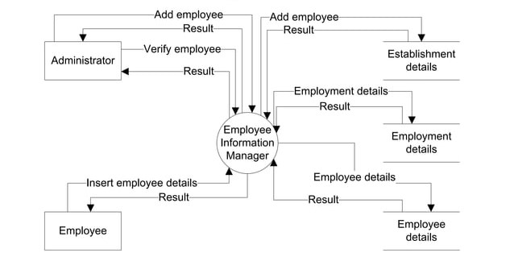

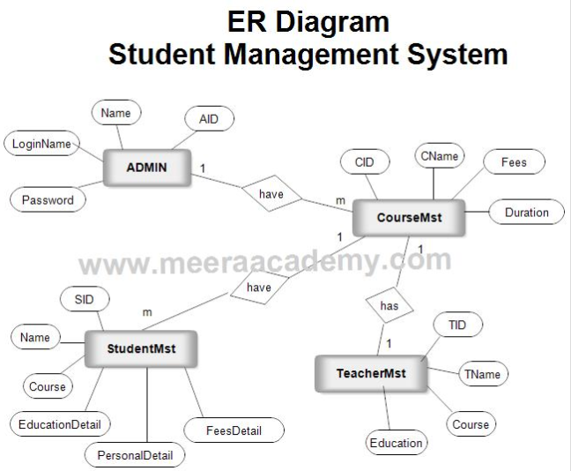

* **Hardware Requirements-**

1. Monitor 21”LED.
2. CPU-Intel P4, 2.66 GHz HT.2MB Cache.
3. 1 GB RAM.
4. 40 GB Hard disk (7200 RPM).
5. Optical Drive CD-RW 48X.
6. Multimedia Keyboard, Optical Mouse.

* **Software Requirements:-**

1. Windows O.S.(XP,2000,WIN8)
2. Microsoft office 2007
3. Microsoft Visual Basic.NET
4. Anti virus Software AVG, QH.
5. Crystal Report

The entire above are used hardware software requirement developing our project named “Hotel Management System”.

**Chapter-5**

**UservManual**

**5.1 User Guideline:-**

Menu Flow





Exit

Admin Login

User Signup

User login

Home



Add School

Personal details





Add Staff

View data



Parent details

Add Principal



School Fees







Reports

Logout

**Chapter-6**

**Input Screens**

**Login Form:-**

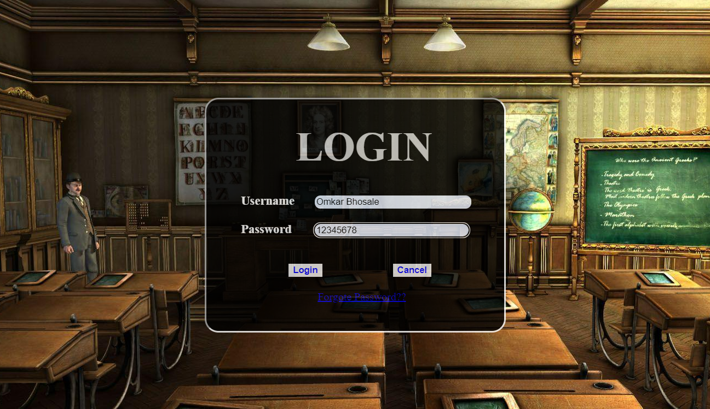

**MDI**:-

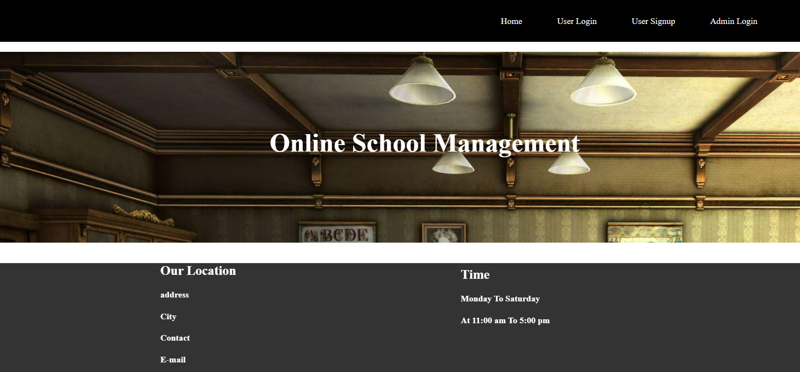

**Admin log:-**

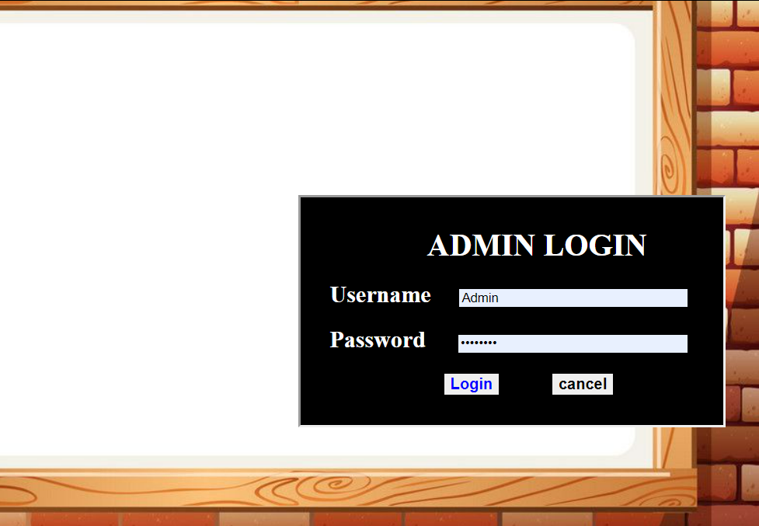

Master page:-

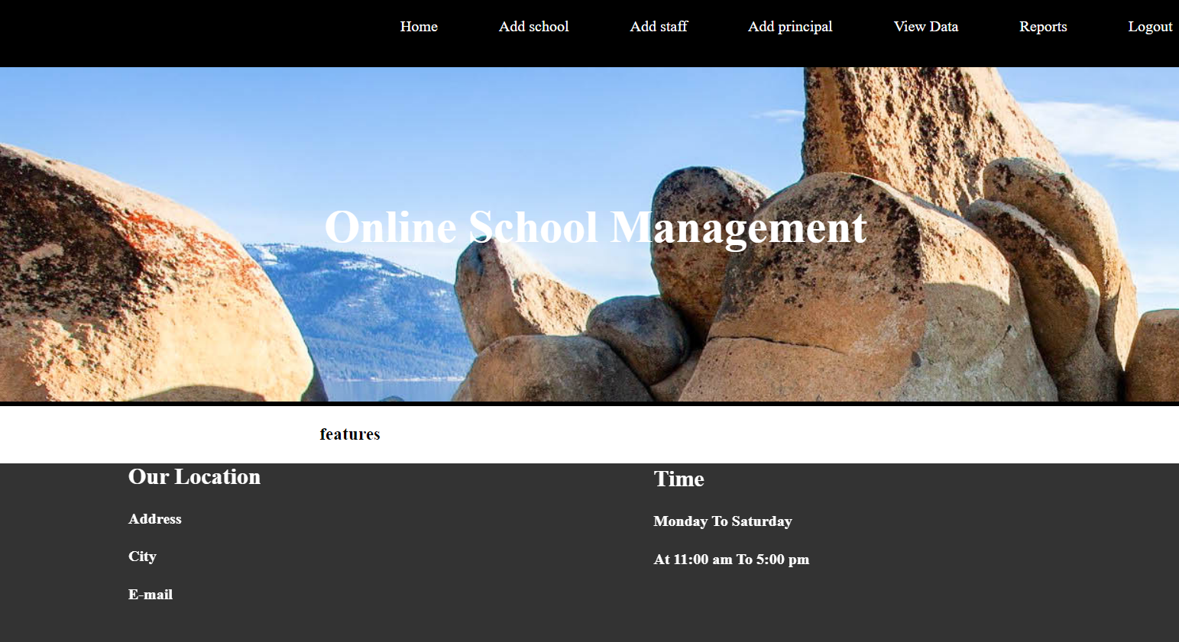

**Add school**:-

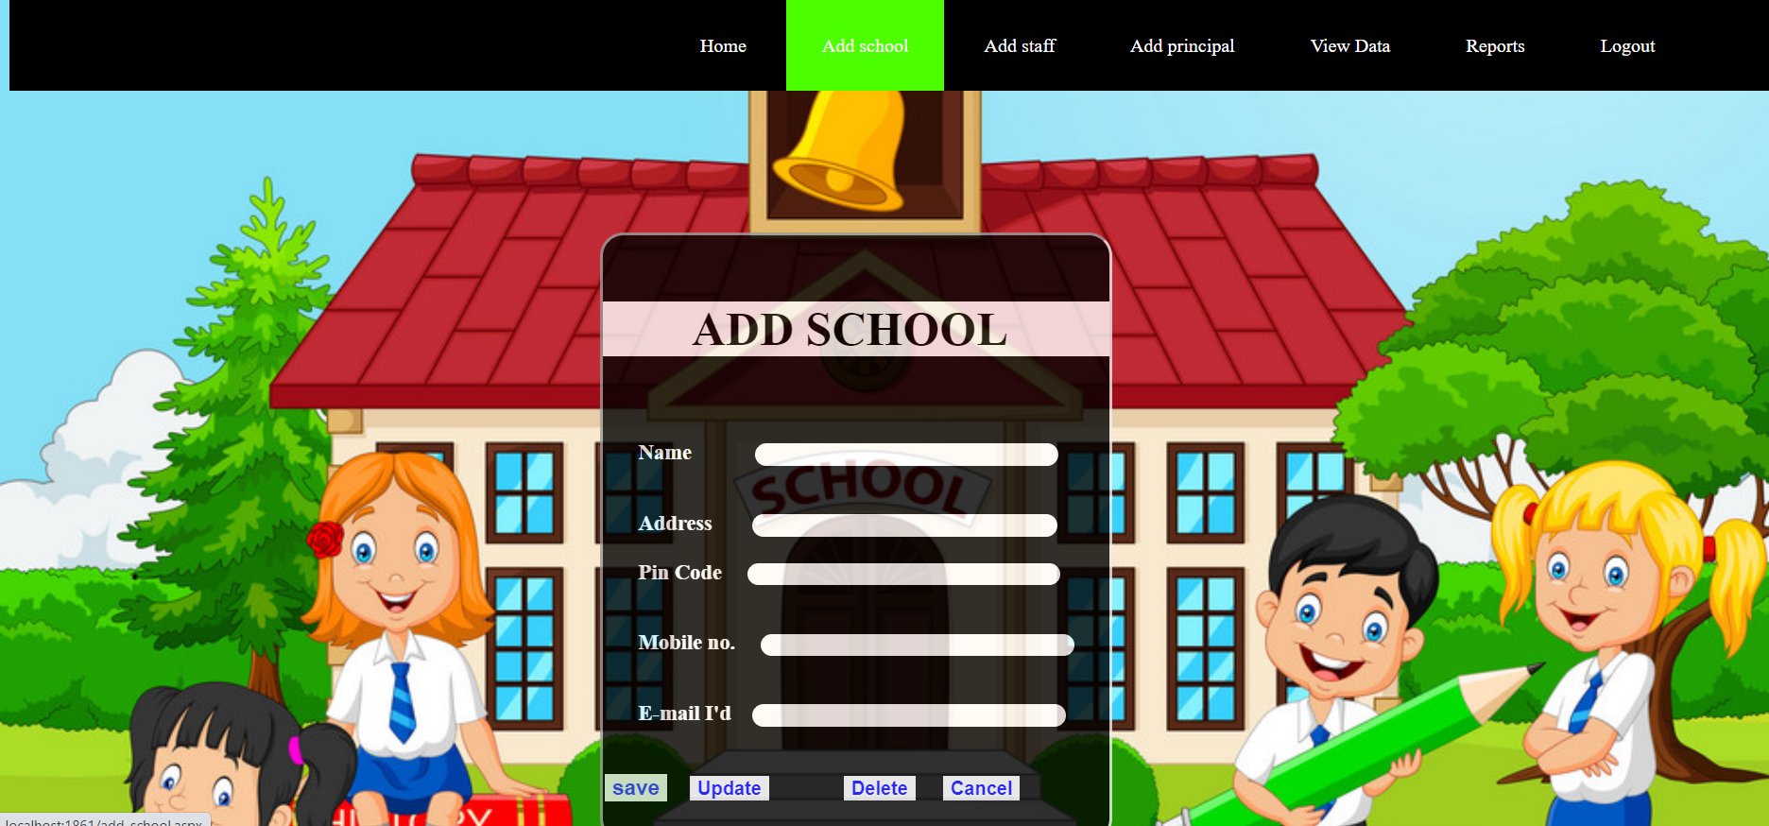

**Staff management:-**

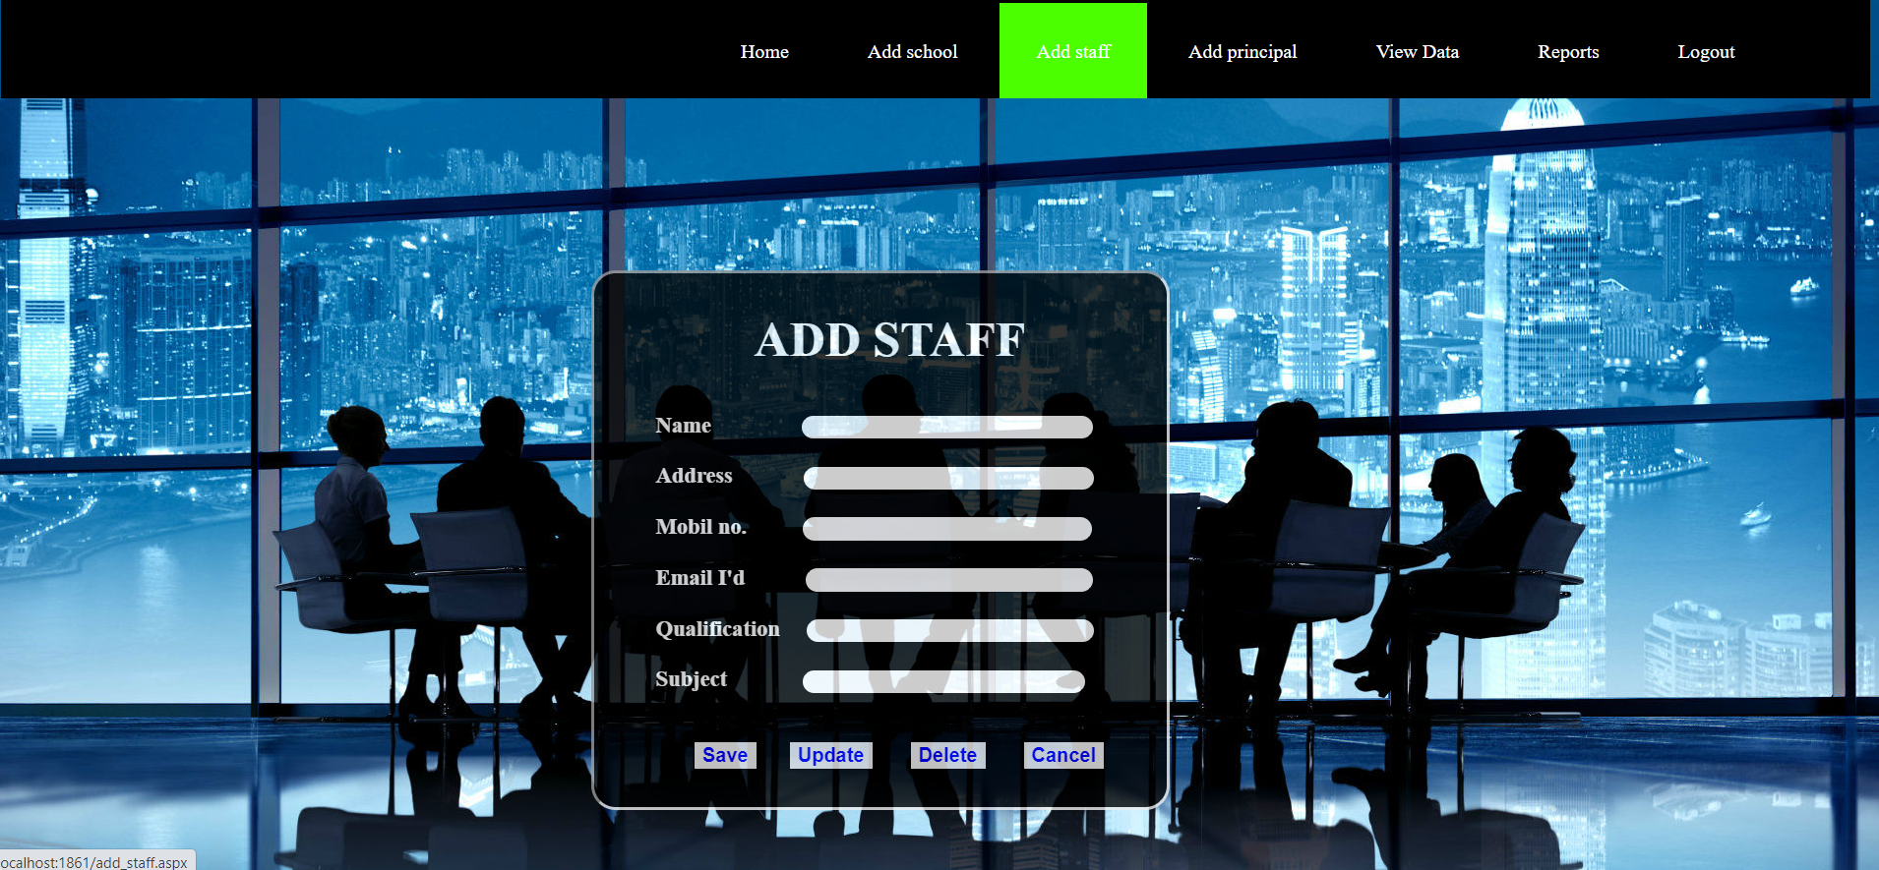

**Add Principal :-**

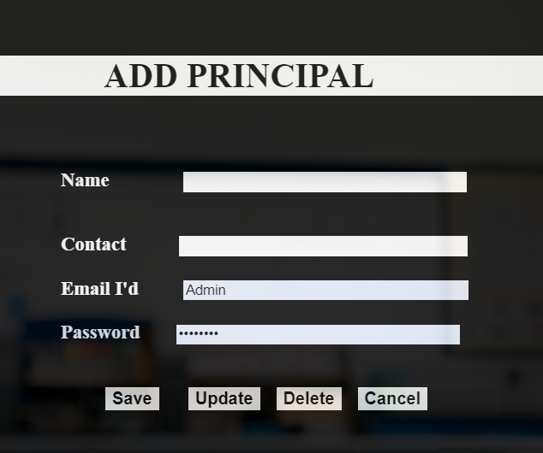

**Student Information:-**

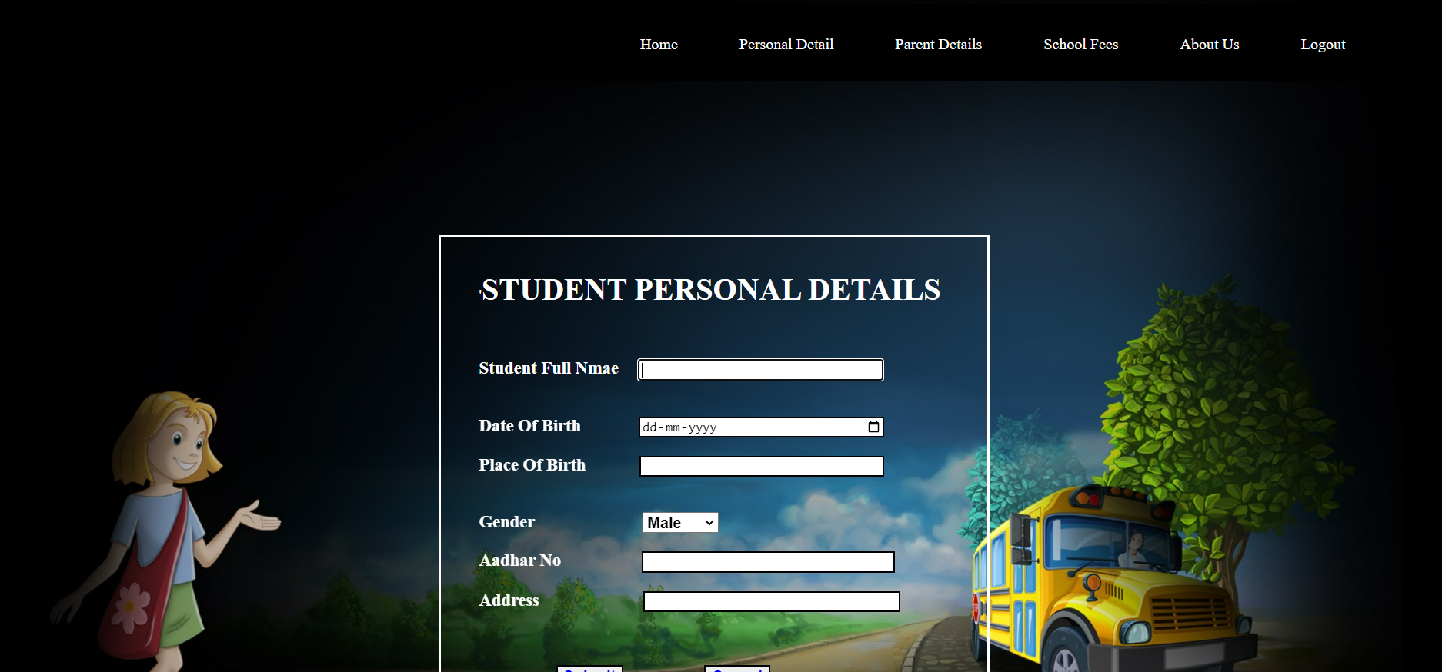

**Parent Information:-**

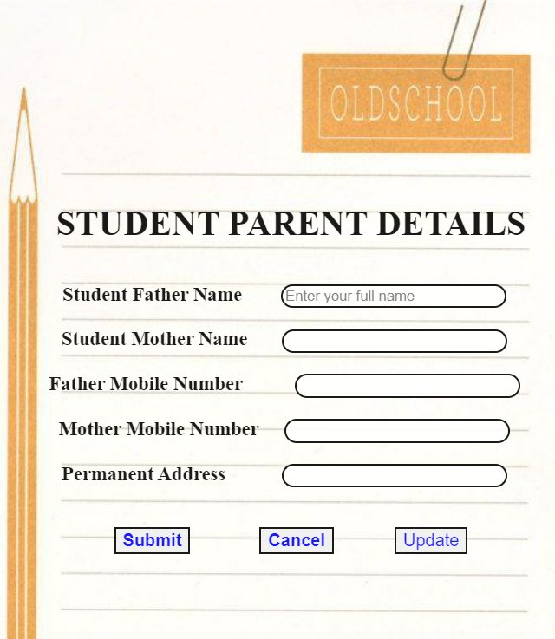

**Fee Detail:-**

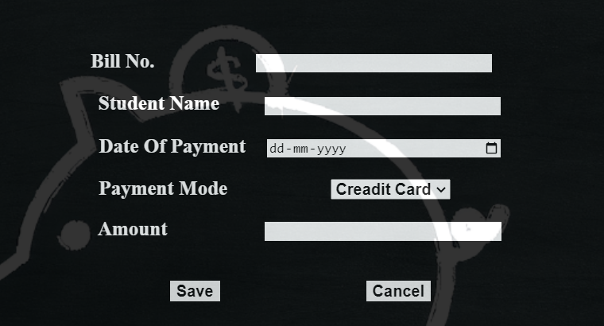

**Chapter-7**

**Output Screens**

**Detail Report:-**

**Student Parents Information:-**

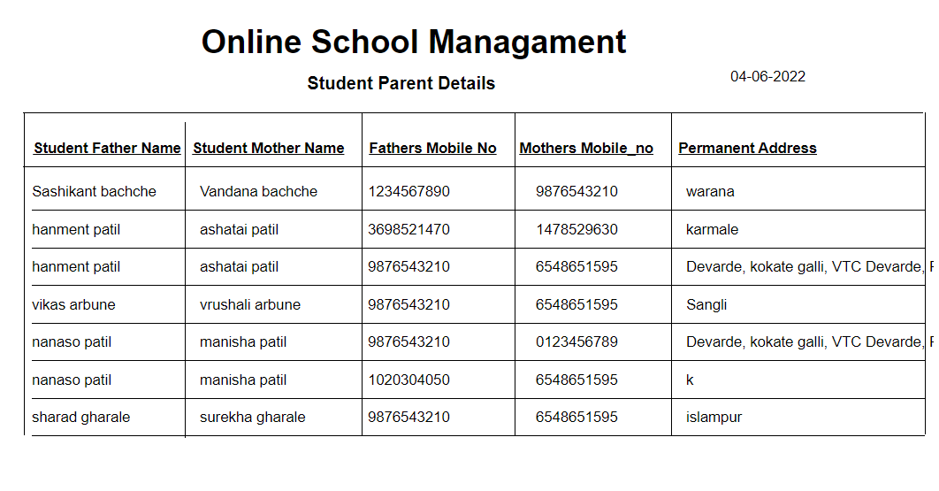

**Fee Detail :-**

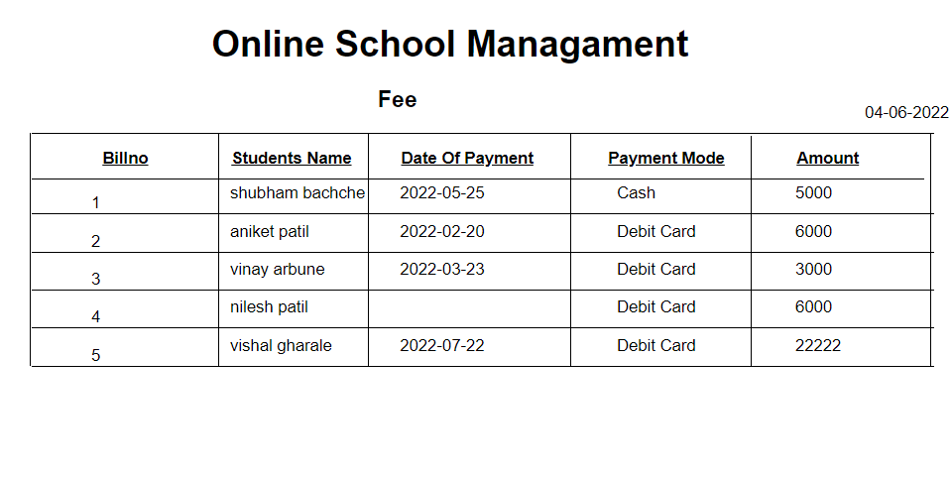

**Academic Details:-**

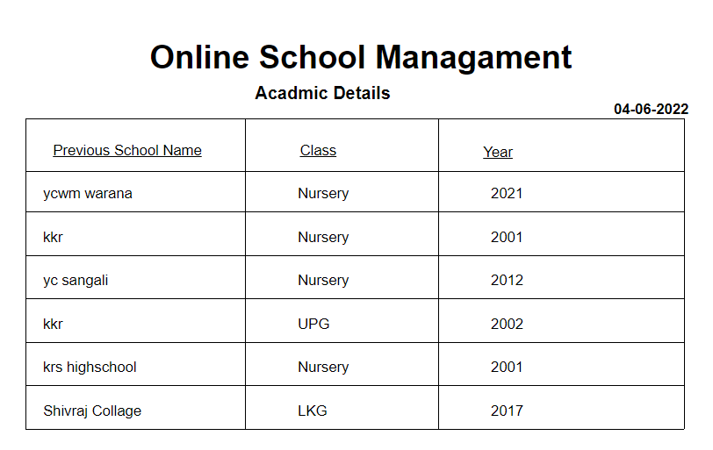

**Sign Details:-**

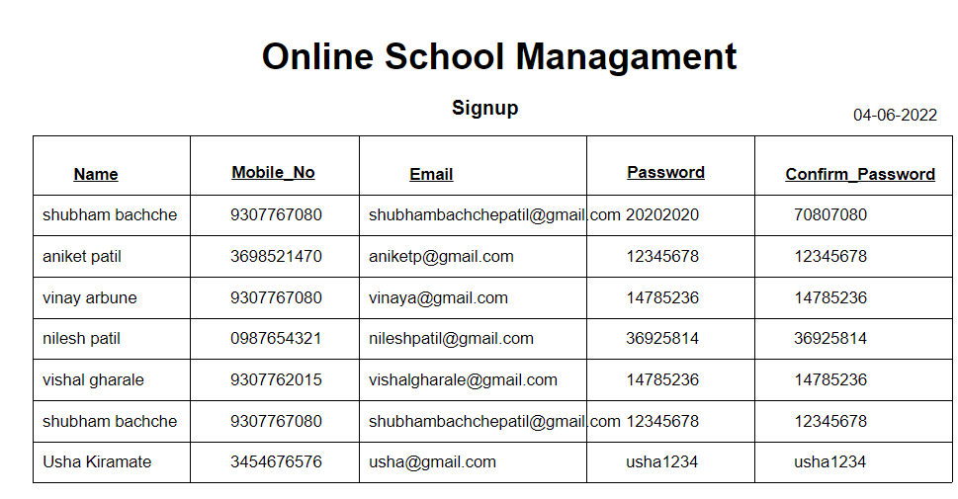

**Chapter-8**

**Limitations and Suggestions**

**Limitations & Suggestions**

Every system has some limitations and because of limitation there is a occurrences of suggestion here we discuss the limitation suggestion of our system “Online School Management system”.

**Limitations:-**

1. This System runs only windows platform
2. This System is not Single user
3. Deleted record cannot be recovered

**Suggestions:-**

1. The user should enter data correctly
2. While getting reports check whether printer is ready or not
3. To start this system ,you have to enter correct password
4. Follow the user manual whenever necessary
5. The user know detail information about the system

**Chapter-9**

**Bibliography**

**Bibliography:-**

**1.** **System Analysis and Design:-**

-By V. Rajaraman

**2. Visual Basic.NET Black Book:-**

-By Steven Holzner.

**3. Analysis and Design of Information System:-**

-By Jemes A.Senn.

**4. Database Management System:-**

-By Raghu amaknishnan and Johanhes Gehrke.